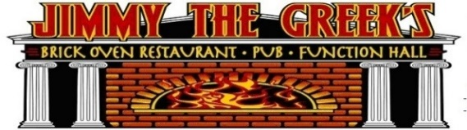
June 2024 PATIO OPEN

 |  7pm  SHIPYARD SPEC. | $2 OFF TITOS  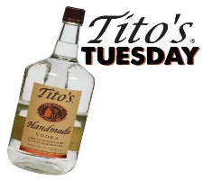 | 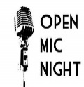  ALL NIGHT HAPPY HR | TALLS  FOR SMALLS | TGIF HAPPY HR   | 1 ROB BENTON 7pm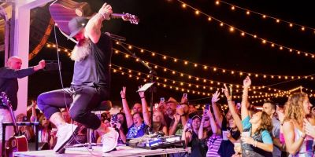  Key West To Maine
2    MUG CLUB | 3 7pm  SHIPYARD SPEC. | 4 | 5  ALL NIGHT HAPPY HR | 6 NBA FINALS GM1  TALLS  FOR SMALLS | 7 TGIF HAPPY HR  KRIS HYPE  6pm | 8  2 For JAcksoN  6 pm
9 NBA FINALS GM2    MUG CLUB | 10 7pm  SHIPYARD SPEC. | 11 | 12 NBA FINALS GM3  ALL NIGHT HAPPY HR | 13  TALLS  FOR SMALLS | 14 NBA FINALS GM4  TGIF HAPPY HR  Pete Grenier  5 pm | 15  Justin carver  6pm
16 FATHERS DAY  STEAK SPECIALS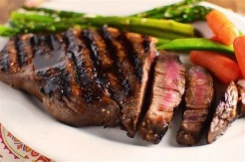 | 17 NBA FINALS GM5  7pm  SHIPYAD SPEC. | 18 | 19  ALL NIGHT HAPPY HR | 20 NBA FINALS GM6  TALLS  FOR SMALLS  KARAOKE w/  ADAM on the patio | 21TGIF HAPPY HR  chris skidgel  6 pm | 22  Matt & Marissa  6 pm
23/30 NBA FINALS GM7  - MUG CLUB  LIVE MUSIC 4-6PM  SAX MAN  SEAN O’ bRIEN | 24  7pm  SHIPYARD SPEC. | 25 | 26  ALL NIGHT HAPPY HR | 27  TALLS  FOR SMALLS  PARTY STARTERS 5pm  On the patio! | 28 TGIF HAPPY HR  Chris james 6pm | 29 808 band 5PM  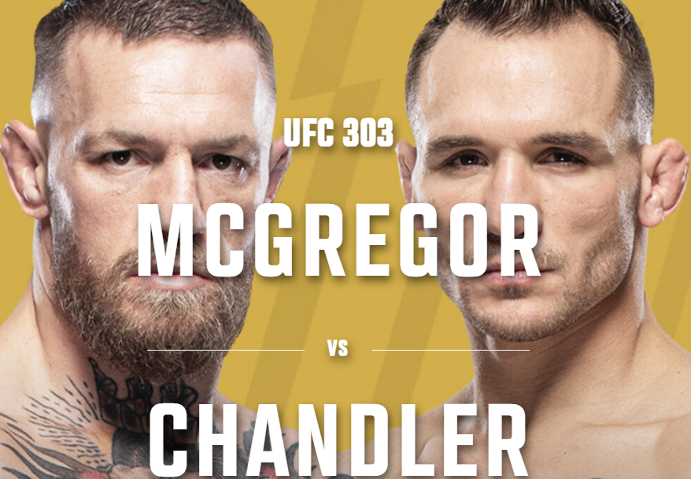  SPECIAL UFC EVENT  MCGREGOR /CHANDLER

